Copyright for test papers and marking guides remains with West Australian Test Papers.
The papers may only be reproduced within the purchasing school according to the advertised conditions of sale.
Test papers must be withdrawn after use and stored securely in the school until June 16 2017.

BIOLOGY
Unit 3
2017

Name: _______________________________________________________

Teacher: ___________________________________________________

Time allowed for this paper

Reading time before commencing work: ten minutes
Working time for the paper: three hours

Materials required/recommended for this paper
To be provided by the supervisor
This Question/Answer booklet
Multiple-choice answer sheet

To be provided by the candidate:
Standard items: Pens (blue/black) preferred, pencils (including coloured), sharpener, correction fluid/tape, eraser, ruler, highlighters

Special items: non-programmable calculators approved for use in this examination

Important note to candidates
No other items may be taken into the examination room. It is your responsibility to ensure that you do not have any unauthorised material. If you have any unauthorised material with you, hand it to the supervisor before reading any further.

Structure of this paper
Section | Number of questions available | Number of questions to be answered | Suggested working time (mins) | Marks available | Percentage of exam | % achieved
Section One:  Multiple-choice | 30 | 30 | 40 | 30 | 30
Section Two:  Short answer | 7 | 7 | 90 | 100 | 50
Section Three:  Extended answer | 4 | 2 | 50 | 40 | 20
 |  |  |  | Total | 100
Instructions to candidates
1. The rules for the conduct of the Western Australian Certificate of Education ATAR course examinations are detailed in the Year 12 Information Handbook 2017. Sitting this examination implies that you agree to abide by these rules.
2. Answer the questions according to the following instructions.
Section One: Answer all questions on the separate Multiple-choice answer sheet provided. For each question, shade the box to indicate your answer. Use only a blue or black pen to shade the boxes. If you make a mistake, place a cross through that square, then shade your new answer. Do not erase or use correction fluid/tape. Marks will not be deducted for incorrect answers. No marks will be given if more than one answer is completed for any question.
Section Two: Write your answers in this Question/Answer booklet. Wherever possible, confine your answers to the line spaces provided.
Section Three: Consists of two parts each with two questions. You must answer one question from each part. Tick the box next to the question you are answering.
3. You must be careful to confine your responses to the specific questions asked and to follow any instructions specific to that particular question.
4. Additional working space pages at the end of this Question/Answer booklet are for planning or continuing an answer. If you use these pages, indicate at the original answer, the page number it is planned/continued on and write the question number being planned/continued on the additional working space page

Section One: Multiple-choice 30% (30 Marks)
This section has 30 questions. Answer all questions on the separate Multiple-choice Answer Sheet provided. For each question shade the box to indicate your answer. Use only a blue or black pen to shade the boxes. If you make a mistake, place a cross through that square, then shade your new answer. do not erase or use correction fluid/tape. Marks will not be deducted for incorrect answers. No marks will be given if more than one answer is completed for any question.
Suggested working time: 40 minutes.

- Lantana camara is a serious bushland weed of eastern Australia and can give
rise to new individuals via vegetative propagation. Which of the following is true of vegetative propagation?

  - Occurs artificially producing genetically identical plants
  - Occurs naturally producing genetically identical plants
  - Can occur both naturally and artificially producing genetically different
plants
  - Can occur both naturally and artificially producing genetically identical
plants

- Eukaryotic chloroplasts and mitochondria, as well as prokaryotic plasmids

  - are circular in shape.
  - replicate only during mitosis.
  - contain double stranded DNA.
  - are composed of histones.

- Protein synthesis involves a number of different molecules. The function of
transfer RNA (tRNA) is to

  - read the messenger RNA (mRNA) and provide a site for protein
synthesis.
  - remain in the nucleus and be replicated.
  - copy the nucleic DNA and transfer the information to the ribosomes.
  - transport amino acids to a triplet code on the mRNA.

- Introns are a sequence of nucleotides found within mRNA or DNA. These
segments

  - contain coding information for proteins.
  - contain noncoding sections.
  - allow for genetic variation due to splicing possibilities.
  - provide structure for the gene.

- Within a single species, the characteristics of individuals are not uniform.
Which of the following is the most likely cause of an unexpected characteristic to appear?

  - Crossing over
  - Random fertilisation
  - Independent assortment
  - Mutation

- Mutations alter the nucleotide sequence of DNA. Which of the following types
of mutations is a result of a piece of a chromosome breaking in two places, reversing and re-joining?

  - Inversion
  - Translocation
  - Deletion
  - Addition

- A hybrid cross between a male zebra (2n=46) and female donkey (2n=64)
produces sterile offspring known as a zonkey. The diploid number of a zonkey would therefore be

  - 23.
  - 32.
  - 55.
  - 108.

- Men more often display recessive sex-linked traits than women. This is due to

  - sex chromosomes being switched off in women.
  - men receiving only one X chromosome containing a recessive allele.
  - sex-linked traits only being carried on the Y chromosome.
  - men receiving two copies of the recessive allele.

- In shorthorn cattle, the roan coat colour is a result of crossing a pure-bred red and
pure-bred white coloured coat parent. This type of inheritance is best known as

  - codominant.
  - polygenic.
  - autosomal.
  - sex-linked.

Use the following pedigree, which shows the pattern of inheritance of long-winged Drosophila melanogaster, to answer Questions 10 and 11.

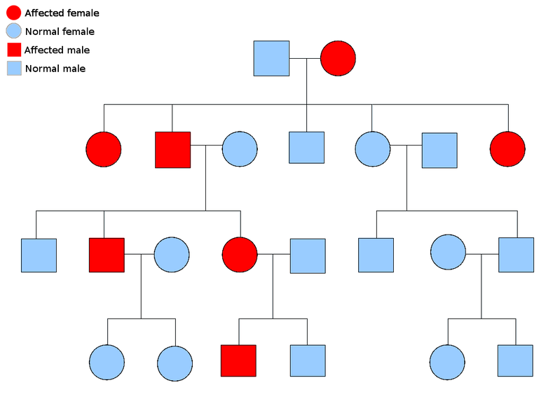
- The mode of inheritance of the long-winged trait shown in the pedigree is
most likely to be

- autosomal codominant.
- autosomal dominant.
- X-linked recessive.
- X-linked dominant.

- If individual III-3 mated with a heterozygous male, the chance that their first offspring
would have the trait is

  - 0%
  - 25%
  - 50%
  - 100%

Use the diagram below to answer Questions 12 and 13.



- The forensic technique demonstrated above that is used to identify
individuals is known as

  - DNA fingerprinting.
  - Polymerase Chain Reaction (PCR).
  - gel electrophoresis.
  - DNA sequencing.

- Short Tandem Repeats (STRs) are used in the forensic technique shown in
the diagram above. What characteristic of STRs make them suitable to be used for DNA identification?

  - Ethnic and racial groups have a different number of STRs
  - The sequence of STRs differs between individuals
  - The number of STRs differs between individuals
  - Male and female STRs have a different sequence

- Agricultural and environmental conservation often involve the use of
biotechnological techniques such as recombinant DNA. Agrobacterium is used to

  - introduce foreign DNA into bacteria.
  - cut DNA at specific locations.
  - activate particular genes in DNA.
  - introduce foreign DNA into a new organism.

- The oldest known fossils are approximately

  - 3.5 million years old.
  - 4.0 million years old.
  - 3.5 billion years old.
  - 4.0 billion years old.

- In which of the following scenarios would a fossil most likely NOT be formed?

  - During a flood, where sediment is deposited quickly
  - Within sandstone, where there are high concentrations of calcite
  - During an ice-age, where temperatures dropped quickly
  - Within metamorphic rock, where a volcanic eruption has occurred

- With technological developments, identification of evolutionary relationships
has advanced. The field that is associated with computer analysis and management of biological data is known as

  - comparative genomics.
  - comparative biochemistry.
  - bioinformatics.
  - genome sequencing.

Use the phylogenetic tree below to answer Question 18.

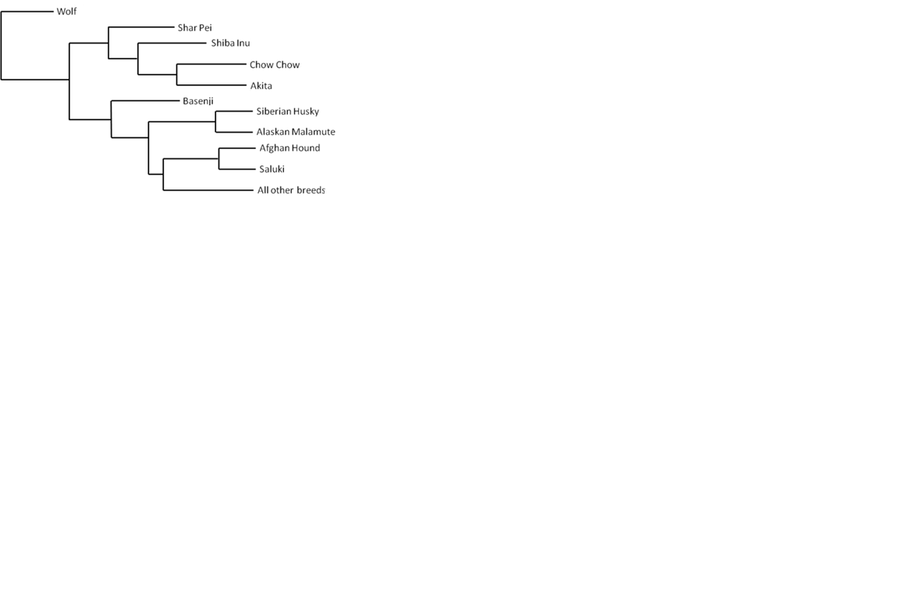

- According to the phylogenetic tree, which two dog breeds are the most closely
related?

  - Saluki and Afghan Hound
  - Saluki and all other breeds
  - Shar-Pei and Basenji
  - Shar-Pei and Akita

Use the diagram below to answer Question 19.

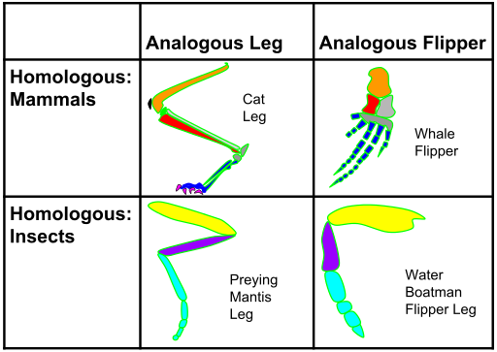
C
D
B
A

- Which pair of the following structures, as depicted in the diagram above, can be used
as evidence for evolution?

  - Structures A and B only
  - Structures A-B and C-D
  - Structures A-C and B-D
  - Structures A-D and B-C

Use the information and graph below to answer Questions 20 to 21.

Since the mid-1940s a number of different pesticides, including organophosphates, have been used in agriculture. Since this time a number of pest species have become resistant.

- The graph above is not formatted to the appropriate scientific standard. Which
of the following changes would resolve the fault?

  - The years and resistant species should be on the alternate axes
  - The vertical and horizontal axes require units
  - The years should start from 0
  - The title should include the dependant and the independent variables

- Which of the following conclusions can be correctly drawn about the use of
pesticides from the graph?

  - Use of pesticides, such as organophosphates, increased in the 1950s
  - The rate of species becoming resistant has declined since the 1980s
  - Over their life-cycle, individuals are becoming more resistant
  - Each species of pest has gradually become more resistant

- The development of pesticide resistance is associated with the concept of the
survival of the fittest, which is defined as

  - the best adapted organism.
  - the organism with the greatest reproductive success.
  - the longest living organism.
  - bigger and stronger organisms.

Use the diagram below to answer Question 23.

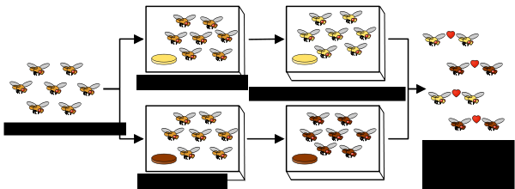

- The experiment shown above best demonstrates

  - natural selection.
  - allopatric speciation.
  - evolution.
  - microevolution.

Use the photograph of the Galapagos tortoise below to answer Question 24.

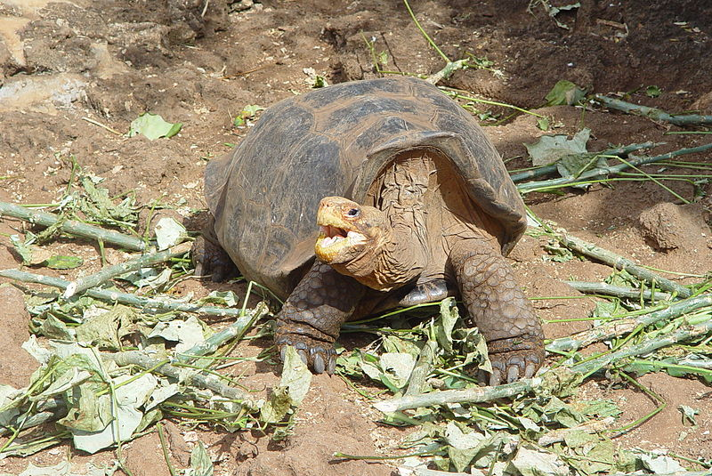

- How might an evolutionary biologist explain why Galapagos tortoises have
evolved saddle-like shells?

  - Large saddle-like shells occurred as a mutation in each member of the
tortoise population
  - Ancestors of the tortoises encountered tall, nutritious shrubs, and
would stretch their necks so much a “saddle” formed in their shell.
  - Some members of the ancestral population had saddle shaped shells.
If this structure was advantageous, they were more likely to survive and reproduce. As such, saddle-like shell tortoises increased in frequency.
  - The ancestors of the tortoise encountered taller, nutritious shrubs.
They needed to develop saddle-like shells to eat and survive, and therefore adapted overtime.

Use the diagram below to answer Questions 25 and 26.
Y
X
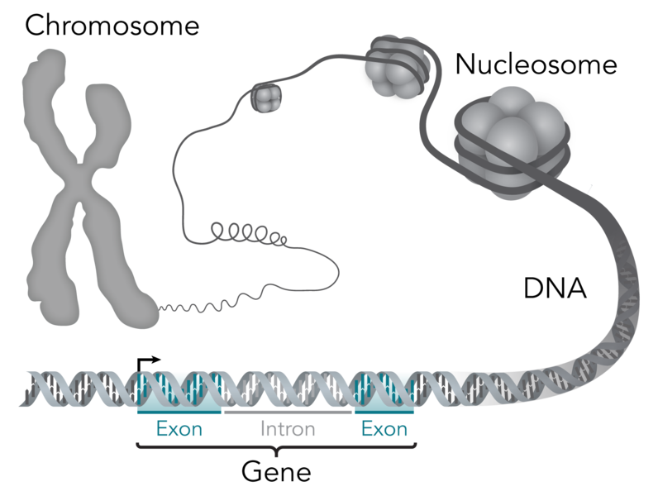

Z

- Structure X consists of

  - DNA.
  - DNA and RNA.
  - DNA and histones.
  - DNA, RNA and histones.

- During protein synthesis, structure Z is unzipped by the enzyme

  - DNA helicase.
  - DNA polymerase.
  - RNA polymerase.
  - DNA ligase.

- Conservationists aim to maintain viable gene pools. This can be achieved
through all of the following except

  - ensuring adequate distribution of organisms throughout the world.
  - studying reproductive behaviours to ensure reproductive success.
  - studying the size and age composition of populations and the
environmental processes behind them.
  - ensuring close family individual breeding to maintain variation.

- Which of the following may cause the bottleneck effect?

  - New colonisation of an island
  - Large scale extermination
  - Non-random mating
  - Random mating

- What is the frequency of the recessive allele in a population of 100 individuals with the following genotypes: 30 RR, 60 Rr and 10 rr?

  - 0.2
  - 0.4
  - 0.6
  - 0.8

- Proteins are large, complex molecules that play many critical roles in organisms. Which of the following is not an example of a protein?

  - Enzymes
  - Antibodies
  - Hormones
  - Glucose

End of Section One

Section Two: Short answer 50% (100 marks)
This section has seven (7) questions. Answer all questions. Write your answers in the spaces provided in this Question/Answer booklet. Wherever possible, confine your answers to the line spaces provided. Use a blue or black pen for this section. Only graphs or diagrams may be drawn in pencil.
Additional working space pages at the end of this booklet are for planning or continuing an answer. If you use these pages, indicate at the original answer, the page number it is planned/continued on and write the question number being planned/continued on the additional working space page.

Suggested working time: 90 minutes.

Question 31 (15 marks)

The diagram below demonstrates the different characteristics of the pea plants studied by Gregor Mendel. These traits were either present or absent in the peas, and those in the top row appeared more often than those in the bottom row.

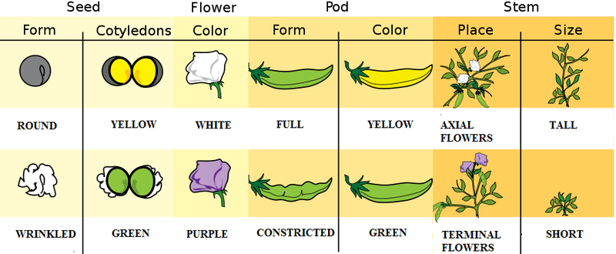

- State the pattern of inheritance attributed to the different characteristics above.
(1 mark)
______________________________________

- i. Assign relevant symbols to the alternative traits associated with coloured
pods. (2 marks)

Allele symbols: Yellow pod ____
Green pod ____

A cross was carried out between two heterozygous, yellow pod, pea plants.

ii. Using a punnet square, calculate the ratio of the expected genotype(s) and phenotype(s) (3 marks)

Genotype: __________________________________

Phenotype: __________________________________

A rabbit gave birth to four baby rabbits. The father had dark brown eyes and the mother yellow eyes. Two of the baby rabbits had brown eyes, one had yellow and the other had blue.

- Explain what this information tells us about the pattern of inheritance for eye colour.
(3 marks)

____________________________________________________________________________________________________________________________________________________________________________________________________________________________________________________________________________

For the alleles to be passed on to the offspring, the chromosomes must be replicated before meiosis.

- Describe the structural property of DNA that allows for accurate replication.
(2 marks)

_________________________________________________________________________________________________________________________________________________________________________________________________________

It has been observed that the phenotype of an organism does not always correspond with the given genotype. The coat colour of domestic cats sometimes lays outside the usual colours of black, brown and cinnamon.

- Explain the relationship between genotypes and phenotypes in regards to the role of the environment on gene expression. (4 marks)

__________________________________________________________________________________________________________________________________________________________________________________________________________________________________________________________________________________________________________________________________________________________________________________________________________________

Question 32 (15 marks)

Among Australia’s key cotton pests is the global insect nemesis of agriculture; Helicoverpa armigera, better known as the bollworm. Since the mid-1990s, Australia’s cotton breeders have begun creating transgenic, or genetically modified, organisms by incorporating genes from a common soil bacterium, Bacillus thuringiensis (Bt). These genes encode for the production of toxic insecticidal proteins.

- Explain the desirable traits that Bt cotton has been engineered for. (3 marks)

____________________________________________________________________________________________________________________________________________________________________________________________________________________________________________________________________________

- Outline the sequence of events most likely undertaken to produce the Bt cotton. (5 marks)

__________________________________________________________________________________________________________________________________________________________________________________________________________________________________________________________________________________________________________________________________________________________________________________________________________________

- As with many technological advances, concerns have been raised in regards to recombinant technology. Discuss the adverse effects that genetically modified crops may have on genetic diversity and the environment. (4 marks)

__________________________________________________________________________________________________________________________________________________________________________________________________________________________________________________________________________________________________________________________________________________________________________________________________________________

DNA sequencing is being applied to agriculture and environmental conservation and is often achieved by using the Sanger method, which utilises dideoxynucleotides (ddNTPs).

- State what DNA sequencing is. (1 mark)

______________________________________________________________________________________________________________________________________

- Describe why ddNTPs are used in the Sanger method of DNA sequencing.
(2 marks)

______________________________________________________________________________________________________________________________________
___________________________________________________________________

Question 33 (7 marks)

Artificial, or selective breeding, is a term utilised by Charles Darwin to help explain the concept of natural selection. It is currently used in the Australian agricultural industry in Australia and allows for the rapid development of individuals with certain desirable traits.

- State the main difference between artificial selection and natural selection. (1 mark)

______________________________________________________________________________________________________________________________________

- Describe how the rapid changes in phenotypes of organisms occur due to artificial selection. (2 marks)

____________________________________________________________________________________________________________________________________________________________________________________________________________________________________________________________________________

The manes of male lions are an example of sexual selection within nature, with lionesses tending to choose males with large, dark manes as mates.

- Describe why these manes are considered sexual selection rather than other forms of selection pressures. (2 marks)

_________________________________________________________________________________________________________________________________________________________________________________________________________

- Gene flow and genetic drift also contribute to allele frequency changes in gene pools. Describe the differences between these two processes of evolution. (2 marks)

________________________________________________________________________________________________________________________________________________________________________________________________________________________________________________________
Question 34 (15 marks)

Some types of evidence, such as fossils and similarities between related living organisms, were used by Darwin to develop his theory of natural selection and are still used today. Others, such as DNA testing, were not available in Darwin's time but are used by scientists today to learn more about evolution.

- Explain how the comparison of embryos provide evidence for evolution. (3 marks)

____________________________________________________________________________________________________________________________________________________________________________________________________________________________________________________________________________

Great white sharks (Carcharodon carcharias) and the bottlenose dolphin (Tursiops) both inhabit the seas off Western Australia and have dorsal fins for stability in the water.

- Explain why these two organisms are not placed in the same class despite these similar characteristics. (3 marks)

____________________________________________________________________________________________________________________________________________________________________________________________________________________________________________________________________________

Life on Earth has both changed and diversified over time.

- State the term given to the chronological timeline of the Earth’s fossils. (1 mark)

___________________________________________________________________

- Describe reasons why this chronological timeline is not complete. (4 marks)

_______________________________________________________________________________________________________________________________________________________________________________________________________________________________________________________________________________________________________________________________________________
- The process of fossilisation is not guaranteed. Summarise the steps of the fossilisation process. (4 marks)

_______________________________________________________________________________________________________________________________________________________________________________________________________________________________________________________________________________________________________________________________________________

Question 35 (15 marks)

A biology class was asked to investigate the effect of the environment on cell division. It was found that onions grown in soil infected with fungal pathogens were found to be exposed to high levels of a protein known as lectin. The class was divided into six groups, with three groups exposing three onion roots to lectin, whilst the other three groups did not expose their three onion roots to lectin. The tips of the onion roots were examined using a microscope and the number of interphase and mitotic cells were counted. The results of the class are shown in the table below.

 | Number of Cells |  | Percentage of Cells (%)
 | Control | Treated | Control | Treated
Interphase Cells | 1055 | 1005
Mitotic Cells | 762 | 2016

- Calculate the percentage of each cell and complete the table above. (4 marks)

- Propose a hypothesis for this experiment. (2 marks)

______________________________________________________________________________________________________________________________________

- i. State the independent variable. (1 mark)

________________________________________________________

- State the dependent variable (1 mark)

________________________________________________________

- Apart from those mentioned above, name two (2) variables that would need to be controlled to ensure the experiment was reliable.
(2 marks)

________________________________________________________
________________________________________________________

- Describe what can be concluded from this data. (2 marks)

___________________________________________________________________
___________________________________________________________________
- Explain the importance of collecting and using multiple trials in scientific experiments. (3 marks)

____________________________________________________________________________________________________________________________________________________________________________________________________________________________________________________________________________

Question 36 (24 marks)

A researcher purified a mouse protein called ‘GFI’ and reverse synthesised it into DNA. The following is the segment of DNA containing the beginning of a gene.

3’ – GGCATATGCGATAGTCGA – 5’
5’ - CCGTATACGCTATCAGCT – 3’

- Explain the relationship between DNA, genes and chromosomes. (3 marks)

____________________________________________________________________________________________________________________________________________________________________________________________________________________________________________________________________________

- Name the enzyme that would transcribe the gene shown above. (1 mark)

___________________________________________________________________

- State whether the top or bottom strand would serve as a template if the enzyme from question (a) above were to transcribe the gene from left to right. (1 mark)

___________________________________________________________________

- Write the sequence of mRNA that will be produced. Include the position of the 3’ and 5’ ends. (2 marks)

___________________________________________________________________

- Describe the three events that occur allowing the mRNA strand to be translated.
(6 marks)
________________________________________________________________________________________________________________________________________________________________________________________________________________________________________________________________________________________________________________________________________________________________________________________________________________________________________________________________________________________________________________________________________________________
- Asides from the change of Thymine to Uracil, describe two (2) other differences between DNA and mRNA in regards to protein synthesis. (4 marks)

_______________________________________________________________________________________________________________________________________________________________________________________________________________________________________________________________________________________________________________________________________________

A scientist studying GFI genes placed mice under different mutagenic conditions. It was found that after exposure, differences in the gene sequence of some mice were noted. One difference is shown below.

Normal Gene: 3’ – GGCATATGCGATAGTCGA – 5’
Altered Gene: 3’ – GGCATATGCCGATAGTCGA – 5’

- State the type of mutation shown above. (1 mark)

___________________________________________________________________

- Define the term mutagen. (1 mark)

______________________________________________________________________________________________________________________________________

- Explain the possible effects of this mutation on the GFI protein. (5 marks)

_______________________________________________________________________________________________________________________________________________________________________________________________________________________________________________________________________________________________________________________________________________

Question 37 (9 marks)

The following information was collated about the phylum Chordata.

 | Vertebrate | Bony Skeleton | Tetrapod | Amniotic Egg | Fenestra | Hair
Sharks |  | × | × | × | × | ×
Ray-Finned Fish |  |  | × | × | × | ×
Amphibians |  |  |  | × | × | ×
Primates |  |  |  |  | ×
Rodents and Rabbits |  |  |  |  | ×
Crocodiles |  |  |  |  |  | ×
Dinosaurs and Birds |  |  |  |  |  | ×

- Use the information from the table above to create a phylogenetic tree in the space below. (6 marks)

- Explain how phylogenetic trees are created and used. (3 marks)

______________________________________________________________________________________________________________________________________

End of Section Two
Section Three: Extended answer 20% (40 Marks)

Section Three consists of four questions.

Answer one question from each section.

Use black or blue pen or ballpoint for written answers and pencil for diagrams. Crossing out of incorrect material is acceptable and preferable to using correction fluid/tape.

Spare pages are included at the end of this booklet. They can be used for planning your responses and/or as additional space if required to continue an answer.
● Planning: if you use the spare pages for planning, indicate clearly at the top of the page.
● Continuing an answer: if you need to use the space to continue an answer, indicate in the original answer space where the answer is continued, i.e. give the page number. Fill in the number of the question that you are continuing to answer at the top of the page.

Suggested working time: 50 minutes.

Unit 3: Choose either Question 38 or Question 39. (20 marks)

Indicate the question you will answer by ticking the box next to the question. Write your answers on pages 27-31. When you have answered your first question, turn to page 34 and indicate the second question you will answer on that page.

Question 38

Yeast is a unicellular fungus that is able to reproduce both asexually, through the process of budding, and sexually, through swapping of genetic material between individuals. Under optimum conditions yeast will reproduce asexually.

- Explain the process of budding and both the advantages and disadvantages of asexual reproduction. (10 marks)

The continuity of life requires the replication of genetic material and its transfer to the next generation.

- Describe the differences between meiosis and mitosis. (10 marks)

Question 39

Through his work on pea plants, Gregor Mendel discovered the fundamental laws of inheritance. Mendel tracked the segregation of parental genes and their appearance in the offspring as dominant or recessive traits.

- State the number of laws of inheritance and explain how each of the following have deviated from Mendel’s conclusions. Include an example of each inheritance.
- Multiple alleles
- Sex-linked (X-linked) inheritance and
- Polygenic (multiple-gene) inheritance. (10 marks)

Variations in the genotype of offspring arise as a result of a number of different processes.

- Asides from mutations, identify three factors that increase genetic diversity and describe how these factors contribute to the genetic diversity of sexually reproducing organisms. (10 marks)

__________________________________________________________________________________________________________________________________________________
_________________________________________________________________________
_________________________________________________________________________
___________________________________________________________________________________________________________________________________________________________________________________________________________________________
_________________________________________________________________________
_________________________________________________________________________
_________________________________________________________________________
__________________________________________________________________________________________________________________________________________________
_________________________________________________________________________
_________________________________________________________________________
_________________________________________________________________________
__________________________________________________________________________________________________________________________________________________
_________________________________________________________________________
_________________________________________________________________________
_________________________________________________________________________
__________________________________________________________________________________________________________________________________________________
_________________________________________________________________________
_________________________________________________________________________
_________________________________________________________________________
__________________________________________________________________________________________________________________________________________________
_________________________________________________________________________
_________________________________________________________________________
_________________________________________________________________________
__________________________________________________________________________________________________________________________________________________
_________________________________________________________________________
_________________________________________________________________________
_________________________________________________________________________
__________________________________________________________________________________________________________________________________________________
_________________________________________________________________________
_________________________________________________________________________
_________________________________________________________________________
__________________________________________________________________________________________________________________________________________________
_________________________________________________________________________
_________________________________________________________________________
_________________________________________________________________________
__________________________________________________________________________________________________________________________________________________
_________________________________________________________________________
_________________________________________________________________________
_________________________________________________________________________
__________________________________________________________________________________________________________________________________________________
_________________________________________________________________________
_________________________________________________________________________
_________________________________________________________________________
__________________________________________________________________________________________________________________________________________________
_________________________________________________________________________
_________________________________________________________________________
_________________________________________________________________________
__________________________________________________________________________________________________________________________________________________
_________________________________________________________________________
_________________________________________________________________________
_________________________________________________________________________
__________________________________________________________________________________________________________________________________________________
_________________________________________________________________________
_________________________________________________________________________
_________________________________________________________________________
__________________________________________________________________________________________________________________________________________________
_________________________________________________________________________
_________________________________________________________________________
_________________________________________________________________________
__________________________________________________________________________________________________________________________________________________
_________________________________________________________________________
_________________________________________________________________________
_________________________________________________________________________
__________________________________________________________________________________________________________________________________________________
_________________________________________________________________________
_________________________________________________________________________
_________________________________________________________________________
__________________________________________________________________________________________________________________________________________________
_________________________________________________________________________
_________________________________________________________________________
_________________________________________________________________________
__________________________________________________________________________________________________________________________________________________
_________________________________________________________________________
_________________________________________________________________________
_________________________________________________________________________
__________________________________________________________________________________________________________________________________________________
_________________________________________________________________________
_________________________________________________________________________
_________________________________________________________________________
__________________________________________________________________________________________________________________________________________________
_________________________________________________________________________
_________________________________________________________________________
_________________________________________________________________________
__________________________________________________________________________________________________________________________________________________
_________________________________________________________________________
_________________________________________________________________________
_________________________________________________________________________
__________________________________________________________________________________________________________________________________________________
_________________________________________________________________________
_________________________________________________________________________
_________________________________________________________________________
__________________________________________________________________________________________________________________________________________________
_________________________________________________________________________
_________________________________________________________________________
_________________________________________________________________________
__________________________________________________________________________________________________________________________________________________
_________________________________________________________________________
_________________________________________________________________________
_________________________________________________________________________
__________________________________________________________________________________________________________________________________________________
_________________________________________________________________________
_________________________________________________________________________
_________________________________________________________________________
__________________________________________________________________________________________________________________________________________________
_________________________________________________________________________
_________________________________________________________________________
_________________________________________________________________________
__________________________________________________________________________________________________________________________________________________
_________________________________________________________________________
Unit 3: Choose either Question 40 or Question 41. (20 marks)

Indicate the question you will answer by ticking the box next to the question. Write your answers on the pages provided.

Question 40

The Ensatina salamander has been extensively investigated because it demonstrates the ongoing process of speciation. Originally there was only one species of salamander, and it was proposed that the species started off in Northern California and Oregon and then spread south along both sides of the Central Valley, which was too dry and hot for salamanders. The diagram below shows the current salamander distribution and phylogeny in California.

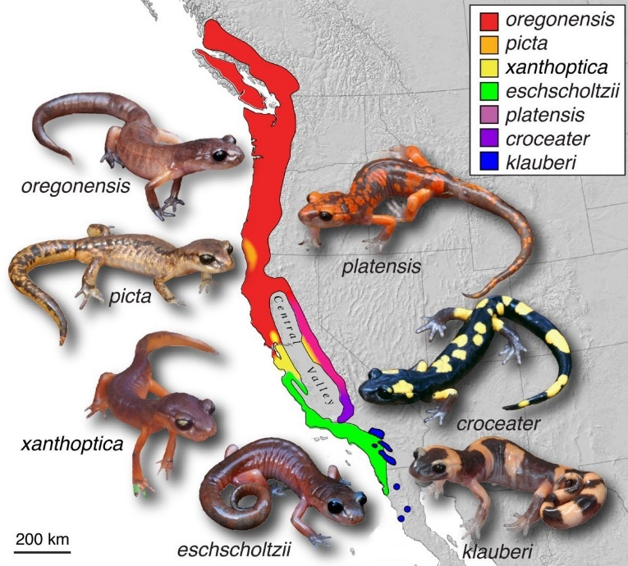

- Describe the evolutionary process that could have led to the development of the different species of salamander. (10 marks)

- Describe two types of comparative genomics and explain how they are used to show the relationships between groups of organisms. (10 marks)

Question 41

Australia Zoo, located north of Brisbane in Queensland Australia, is involved in a variety of wildlife and wilderness conservation projects. Priority species include the Baudin's black cockatoos (Calyptorhynchus baudinii), which are found in the Southwest of Australia and nowhere else in the world. They have disappeared from over 25% of their former range, mainly due to habitat loss for urban development, forestry and mining operations. However, the single greatest and most urgent threat facing this species is illegal shooting. The black cockatoo is currently listed as endangered.

- Explain why conservation programs, such as those run at Australia Zoo, use biogeography, reproductive behaviour and population size to increase viable gene pools.
(10 marks)

Because reduced genetic diversity can occur in small populations, it is important that for endangered populations, like the Baudin’s black cockatoo, genetic records are kept for when breeding partners are selected.

- Explain the biotechnological processes that may be used to assess gene pools for breeding programs like those at the Australian Zoo.

__________________________________________________________________________________________________________________________________________________
_________________________________________________________________________
_________________________________________________________________________
___________________________________________________________________________________________________________________________________________________________________________________________________________________________
_________________________________________________________________________
_________________________________________________________________________
_________________________________________________________________________
__________________________________________________________________________________________________________________________________________________
_________________________________________________________________________
_________________________________________________________________________
_________________________________________________________________________
__________________________________________________________________________________________________________________________________________________
_________________________________________________________________________
_________________________________________________________________________
_________________________________________________________________________
__________________________________________________________________________________________________________________________________________________
_________________________________________________________________________
_________________________________________________________________________
_________________________________________________________________________
__________________________________________________________________________________________________________________________________________________
_________________________________________________________________________
_________________________________________________________________________
_________________________________________________________________________
__________________________________________________________________________________________________________________________________________________
_________________________________________________________________________
_________________________________________________________________________
_________________________________________________________________________
__________________________________________________________________________________________________________________________________________________
_________________________________________________________________________
_________________________________________________________________________
_________________________________________________________________________
__________________________________________________________________________________________________________________________________________________
_________________________________________________________________________
_________________________________________________________________________
_________________________________________________________________________
__________________________________________________________________________________________________________________________________________________
_________________________________________________________________________
_________________________________________________________________________
_________________________________________________________________________
__________________________________________________________________________________________________________________________________________________
_________________________________________________________________________
_________________________________________________________________________
_________________________________________________________________________
__________________________________________________________________________________________________________________________________________________
_________________________________________________________________________
_________________________________________________________________________
_________________________________________________________________________
__________________________________________________________________________________________________________________________________________________
_________________________________________________________________________
_________________________________________________________________________
_________________________________________________________________________
__________________________________________________________________________________________________________________________________________________
_________________________________________________________________________
_________________________________________________________________________
_________________________________________________________________________
__________________________________________________________________________________________________________________________________________________
_________________________________________________________________________
_________________________________________________________________________
_________________________________________________________________________
__________________________________________________________________________________________________________________________________________________
_________________________________________________________________________
_________________________________________________________________________
_________________________________________________________________________
__________________________________________________________________________________________________________________________________________________
_________________________________________________________________________
_________________________________________________________________________
_________________________________________________________________________
__________________________________________________________________________________________________________________________________________________
_________________________________________________________________________
_________________________________________________________________________
_________________________________________________________________________
__________________________________________________________________________________________________________________________________________________
_________________________________________________________________________
_________________________________________________________________________
_________________________________________________________________________
__________________________________________________________________________________________________________________________________________________
_________________________________________________________________________
_________________________________________________________________________
_________________________________________________________________________
__________________________________________________________________________________________________________________________________________________
_________________________________________________________________________
_________________________________________________________________________
_________________________________________________________________________
__________________________________________________________________________________________________________________________________________________
_________________________________________________________________________
_________________________________________________________________________
_________________________________________________________________________
__________________________________________________________________________________________________________________________________________________
_________________________________________________________________________
_________________________________________________________________________
_________________________________________________________________________
__________________________________________________________________________________________________________________________________________________
_________________________________________________________________________
_________________________________________________________________________
_________________________________________________________________________
__________________________________________________________________________________________________________________________________________________
_________________________________________________________________________
_________________________________________________________________________
_________________________________________________________________________
__________________________________________________________________________________________________________________________________________________
_________________________________________________________________________
_________________________________________________________________________
_________________________________________________________________________
__________________________________________________________________________________________________________________________________________________
_________________________________________________________________________
_________________________________________________________________________
_________________________________________________________________________
__________________________________________________________________________________________________________________________________________________
_
ACKNOWLEDGEMENTS
Question 10-11
Pedigree
https://commons.wikimedia.org/wiki/File:Autosomal_dominant.png

Question 12-13
Electrophoresis
https://www.shutterstock.com/pic-199347557/stock-vector-gel-electrophoresis-separation-electrophoretogram-result-vector-illustration.html?src=YNVzvMB-WgPNVqP457SFAQ-1-18

Question 18
Phylogenetic Tree
https://commons.wikimedia.org/wiki/File:Phylogenetic_tree_of_ancient_dog_breeds.png

Question 19
Homologous and Analogous Structures
https://commons.wikimedia.org/wiki/File:Analogous_%26_Homologous_Structures.svg

Question 23
Speciation
https://commons.wikimedia.org/wiki/File:Speciation_experiment.svg

Question 24
Galapagos Tortoise
https://commons.wikimedia.org/wiki/File:Gal%C3%A1pagos_tortoise_Santa_Cruz_Island_Gal%C3%A1pagos_Ecuador_DSC00253_ad.JPG?uselang=en-gb

Question 25-26
Chromosome and DNA
https://commons.wikimedia.org/wiki/File:Chromosome-DNA-gene.png

Question 31
Mendel Characteristics https://commons.wikimedia.org/wiki/Gregor_Mendel#/media/File:Mendel_seven_characters.svg

Question 40
Salamander Evolution
https://upload.wikimedia.org/wikipedia/commons/e/e3/Ensatina_eschscholtzii_ring_species.jpg

WATP acknowledges the permission of School Curriculum and Assessment Authority in
providing instructions to students.

